Exibir menu quando a pessoa estiver logado

Adicionar Rota

*/*CLIENT*/*.state(**'client'**, {  
 **abstract**: **true**,  
 **url**:**'/client'**,  
 **templateUrl**:**'templates/client/menu.html'**,  
 **controller**: **'ClientMenuCtrl'**})

Criar Template de Menu em Client

Criar Controller de Menu em Client

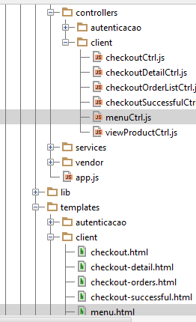

Chamar Controller na Index

<**script src="js/controllers/client/menuCtrl.js"**></**script**>

Controller MenuClientCtrl

**angular**.module(**'starter.controllers'**).**controller**(**'ClientMenuCtrl'**,[  
 **'$scope'**, **'$state'**, **'$ionicLoading'**, **'User'**,  
 **function** ($scope, $state, $ionicLoading, User) {  
 $scope.**user** = {  
 **name**: **''** };  
 $ionicLoading.**show**({  
 **template**: **'Carregando...'** });  
 User.**authenticated**({}, **function**(data) {  
 $scope.**user** = data.data;  
 $ionicLoading.**hide**();  
 }, **function**(dataError) {  
 $ionicLoading.**hide**();  
 });  
  
 }]);